BIT4107 – Mobile Application Development Logbook
Student Name: Joyce Kyalo
Admission Number: BIT/2024/50441
School/Faculty: School of Computing and Informatics
Programme: Mobile Application Development
Academic Year: 3
Semester: 2
Lecturer: Nyoro
Phone Number: 0729611280

Week 1: Introduction to Mobile Application Development
Practical Activities Undertaken: Studied and implemented concepts related to Introduction to Mobile Application Development using Android Studio and Kotlin.
Screenshots/Evidence Attached: Yes
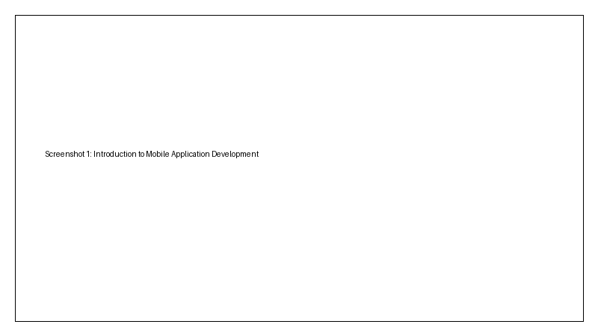
Tools/Software Used: Android Studio, Emulator, Kotlin, XML
Personal Reflection: Gained practical understanding and improved mobile application development skills through hands-on exercises.

Week 2: Mobile Development Environment
Practical Activities Undertaken: Studied and implemented concepts related to Mobile Development Environment using Android Studio and Kotlin.
Screenshots/Evidence Attached: Yes

Tools/Software Used: Android Studio, Emulator, Kotlin, XML
Personal Reflection: Gained practical understanding and improved mobile application development skills through hands-on exercises.

Week 3: User Interface Design
Practical Activities Undertaken: Studied and implemented concepts related to User Interface Design using Android Studio and Kotlin.
Screenshots/Evidence Attached: Yes

Tools/Software Used: Android Studio, Emulator, Kotlin, XML
Personal Reflection: Gained practical understanding and improved mobile application development skills through hands-on exercises.

Week 4: Event Handling and User Interaction
Practical Activities Undertaken: Studied and implemented concepts related to Event Handling and User Interaction using Android Studio and Kotlin.
Screenshots/Evidence Attached: Yes

Tools/Software Used: Android Studio, Emulator, Kotlin, XML
Personal Reflection: Gained practical understanding and improved mobile application development skills through hands-on exercises.

Week 5: Data Management
Practical Activities Undertaken: Studied and implemented concepts related to Data Management using Android Studio and Kotlin.
Screenshots/Evidence Attached: Yes

Tools/Software Used: Android Studio, Emulator, Kotlin, XML
Personal Reflection: Gained practical understanding and improved mobile application development skills through hands-on exercises.

Week 6: Networking and APIs
Practical Activities Undertaken: Studied and implemented concepts related to Networking and APIs using Android Studio and Kotlin.
Screenshots/Evidence Attached: Yes

Tools/Software Used: Android Studio, Emulator, Kotlin, XML
Personal Reflection: Gained practical understanding and improved mobile application development skills through hands-on exercises.

Week 7: Application Architecture
Practical Activities Undertaken: Studied and implemented concepts related to Application Architecture using Android Studio and Kotlin.
Screenshots/Evidence Attached: Yes

Tools/Software Used: Android Studio, Emulator, Kotlin, XML
Personal Reflection: Gained practical understanding and improved mobile application development skills through hands-on exercises.

Week 8: Project Planning
Practical Activities Undertaken: Studied and implemented concepts related to Project Planning using Android Studio and Kotlin.
Screenshots/Evidence Attached: Yes

Tools/Software Used: Android Studio, Emulator, Kotlin, XML
Personal Reflection: Gained practical understanding and improved mobile application development skills through hands-on exercises.

Week 9: Device Features and Sensors
Practical Activities Undertaken: Studied and implemented concepts related to Device Features and Sensors using Android Studio and Kotlin.
Screenshots/Evidence Attached: Yes

Tools/Software Used: Android Studio, Emulator, Kotlin, XML
Personal Reflection: Gained practical understanding and improved mobile application development skills through hands-on exercises.

Week 10: Notifications and Background Services
Practical Activities Undertaken: Studied and implemented concepts related to Notifications and Background Services using Android Studio and Kotlin.
Screenshots/Evidence Attached: Yes

Tools/Software Used: Android Studio, Emulator, Kotlin, XML
Personal Reflection: Gained practical understanding and improved mobile application development skills through hands-on exercises.

Week 11: Mobile Security
Practical Activities Undertaken: Studied and implemented concepts related to Mobile Security using Android Studio and Kotlin.
Screenshots/Evidence Attached: Yes

Tools/Software Used: Android Studio, Emulator, Kotlin, XML
Personal Reflection: Gained practical understanding and improved mobile application development skills through hands-on exercises.

Week 12: Testing and Debugging
Practical Activities Undertaken: Studied and implemented concepts related to Testing and Debugging using Android Studio and Kotlin.
Screenshots/Evidence Attached: Yes
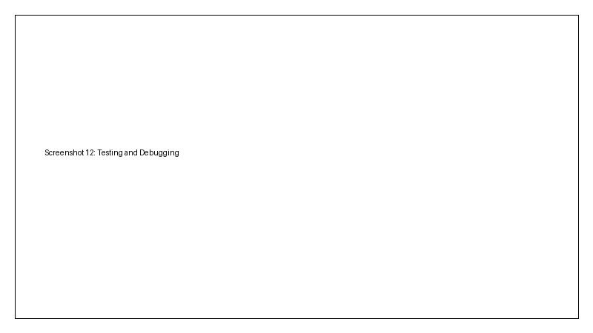
Tools/Software Used: Android Studio, Emulator, Kotlin, XML
Personal Reflection: Gained practical understanding and improved mobile application development skills through hands-on exercises.

Week 13: Application Deployment
Practical Activities Undertaken: Studied and implemented concepts related to Application Deployment using Android Studio and Kotlin.
Screenshots/Evidence Attached: Yes
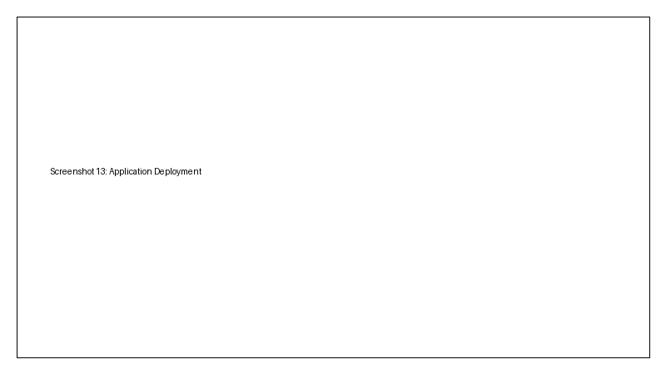
Tools/Software Used: Android Studio, Emulator, Kotlin, XML
Personal Reflection: Gained practical understanding and improved mobile application development skills through hands-on exercises.

Week 14: Final Project Presentation
Practical Activities Undertaken: Studied and implemented concepts related to Final Project Presentation using Android Studio and Kotlin.
Screenshots/Evidence Attached: Yes

Tools/Software Used: Android Studio, Emulator, Kotlin, XML
Personal Reflection: Gained practical understanding and improved mobile application development skills through hands-on exercises.

Semester Project Tracking
Project Title: SmartPark – Car Parking Management System
Project Objectives: Manage parking spaces, drivers, attendants, bookings and reports.
Project Requirements: Android Studio, Kotlin, SQLite, XML layouts.
Development Milestones: Requirements analysis, UI design, implementation, testing and deployment.
Testing Results: Core features functioned successfully with minor issues corrected during debugging.
Lessons Learned: Importance of planning, testing and user-friendly interfaces.
Future Improvements: Cloud backend, online payments and real-time parking updates.

End of Semester Reflection
Summary of Skills Acquired: Android development, UI design, event handling, data management, APIs, testing and deployment.
Most Interesting Topic: User Interface Design.
Major Challenges Faced: Debugging and application integration.
How Challenges Were Overcome: Research, testing and lecturer guidance.
Professional Growth Achieved: Improved software development and problem-solving skills.
Overall Course Experience: Practical and beneficial for mobile development career growth.
Lecturer Remarks: __________________________
Lecturer Signature: ________________________

